Exercise 3:

1. Above each line, use the # to write a comment to yourself explaining what the line does

Output:

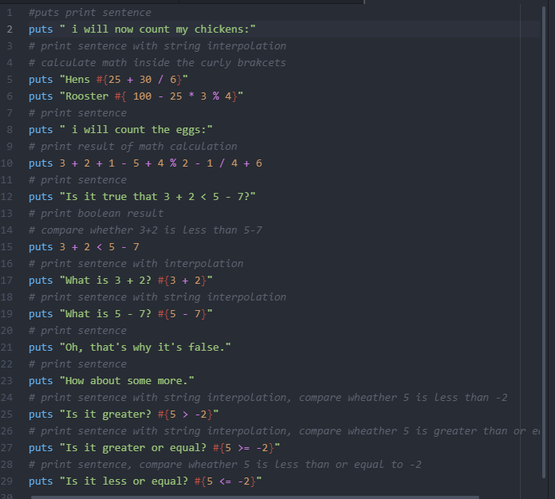

2.Remember in exercise o when you started irb? Start irb this way again and, using the math operators, use ruby as a calculator.

Output:

I typed irb in terminal to start interactive ruby. Here some math calculation I did. I used floating point numbers and integers and less than, greater than to compare the results of math calculations.

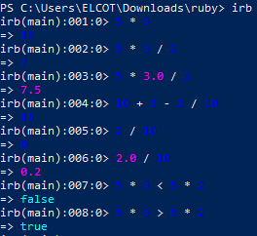

3.Find something you need to calculate and write a new .rb file that does it

Question:

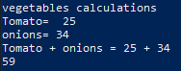

Output:

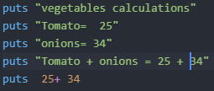

4.Rewrite ex3.rb to use floating point numbers so it’s more accurate.20.0 is floating point.

Output:

